AI-Driven Burnout and Mental Health Prediction
Divya M
Department of Computer Science and Engineering
Rajalakshmi Engineering College
Chennai, India
divya.m@rajalakshmi.edu.in
Ritika Taphasvi G
Department of Computer Science and Engineering
Rajalakshmi Engineering College
Chennai, India
230701266@rajalakshmi.edu.in
Dhivya Shree K
Department of Computer Science and Engineering
Rajalakshmi Engineering College
Chennai, India
230701079@rajalakshmi.edu.in
Abstract— Employee well-being has become a crucial concern in the modern workplace, where demanding workloads, irregular schedules, and hybrid work models have increased stress and burnout levels. This paper presents an AI-driven burnout and mental health prediction system that analyzes daily employee inputs such as work hours, sleep quality, mood, focus, and stress levels to assess mental wellness. The system integrates a psychological burnout score formula and a machine learning model (Random Forest) to classify burnout risk as Low, Medium, or High in real time. A secure and responsive web application, built using React and Tailwind CSS, allows users to log daily data, while Supabase manages authentication and cloud storage. The backend API processes inputs, predicts burnout levels, and provides personalized wellness recommendations. This approach combines behavioral science and artificial intelligence to deliver early burnout detection and proactive mental health support, ultimately improving workplace well-being and productivity. The model achieved an accuracy of 89.56% and an F1-score of 84.37%, demonstrating high reliability in real-time prediction. By integrating psychological principles with data analytics, the system bridges the gap between technology and human emotion. Its modular architecture allows scalability across diverse organizations, making it a practical tool for employee wellness management. Future enhancements include wearable integration and voice-based emotion analysis to further strengthen predictive insights.
Keywords—Burnout Prediction, Mental Health, Machine Learning, Artificial Intelligence, Employee Wellness, Random Forest, Supabase

Introduction
The growing demands of the modern digital workplace have led to a significant rise in stress, anxiety, and employee burnout. Burnout is a psychological condition characterized by exhaustion, lack of focus, and emotional fatigue that negatively affects both personal health and professional performance. According to global studies, nearly 70% of professionals experience symptoms of burnout, yet few organizations possess systems capable of detecting it early.
Traditional wellness programs rely on surveys and static assessments, which fail to capture the daily variations in employee behavior and emotions. To address this issue, an AI-based burnout prediction system is proposed that leverages both psychological assessment metrics and machine learning techniques. The proposed system analyzes daily behavioral inputs—workload, stress level, sleep quality, and mood—to predict burnout risk dynamically.
The model’s predictive component uses Random Forest classification, trained on behavioral and well-being features, while a rule-based burnout score formula computes real-time well-being indicators. Users can access this system through a simple web interface that displays personalized insights and recommendations. The combination of AI analytics with behavioral science makes this solution effective for continuous monitoring and early intervention.
AI-based tools have been increasingly used in mental health monitoring, including conversational AI systems and chatbots designed for emotional support [1][3]. These systems have proven capable of delivering scalable, accessible mental health care solutions [4] [5]. Inspired by such research, the proposed model extends these ideas to workplace wellness through predictive analytics.
The rest of the paper is organized as follows: Section II introduces the literature survey. Section III deals with the proposed system and methodology. Implementation research is discussed in section IV followed by conclusion in section V.

Literature Survey

Numerous studies have explored AI applications in mental health and stress detection. Al-Tameemi and Chowdhury [1] developed an AI chatbot for student mental health, emphasizing the role of AI in early emotional intervention. Arora and Mehta [2] conducted a randomized trial on a generative AI chatbot (Therabot) and demonstrated improved therapy engagement through adaptive conversational responses.
Johnson and Singh [3] analyzed the effectiveness of chatbots for adolescent depression management, concluding that conversational AI fosters emotional openness. Kowalski and Nowak [4] introduced a web and mobile therapy chatbot for subclinical young adults, highlighting the potential of hybrid conversational systems in long-term mental support.
Kumar and Patel [5] examined the impact of chatbot personality on user engagement and found that emotionally adaptive chatbots increase user satisfaction. Li and Zhang [6] performed a meta-analysis of chatbot interventions, confirming that AI-based mental health systems significantly reduce symptoms of anxiety and loneliness. Liu and Zhou [7] presented “Emohaa,” a CBT-based chatbot that integrates natural language processing for real-time emotional regulation.
O’Shea and Williams [8] evaluated ChatPal’s usability and trustworthiness in mental health contexts, emphasizing ethical AI design. Rogers and Hughes [9] conducted a systematic review of AI conversational agents, concluding that predictive personalization enhances treatment adherence. Wei and Chen [10] validated a CBT-based AI chatbot that reduced depression and loneliness through consistent cognitive-behavioral guidance.
These studies collectively support the feasibility of AI-driven solutions for mental health management and serve as the theoretical foundation for the proposed burnout prediction model.

Proposed System

The Proposed System introduces an intelligent, data-driven approach to predicting employee burnout by combining psychological evaluation methods with machine learning algorithms. The system is designed to continuously monitor user inputs—such as stress, sleep, focus, and mood—and process them through both a rule-based scoring formula and a trained Random Forest classifier. This dual approach ensures interpretability, allowing the system to provide transparent results along with personalized recommendations. The entire solution is implemented as a web-based application that emphasizes real-time feedback, data security, and accessibility, offering users a seamless experience to self-assess their mental wellness and take preventive actions before burnout intensifies.

Dataset

The dataset consists of daily self-assessment inputs provided by users via a web-based form. Each input corresponds to behavioral or physiological parameters influencing burnout risk:
- Work hours
- Sleep duration and quality
- Stress level
- Mood score
- Focus and workload intensity
- Physical activity and social engagement
These variables form the feature set for burnout score computation and model training. The dataset is securely stored in the Supabase cloud, which ensures authentication, encryption, and accessibility.

Data Preprocessing
Data preprocessing ensures consistency and reliability before feeding data into the model. Missing or invalid entries are filtered, and numerical normalization is performed to align scales. Categorical values (such as mood ratings) are encoded numerically. Data validation rules are applied in the frontend to prevent unrealistic entries. The processed data is then sent to the backend for burnout score calculation and prediction.
In addition to basic validation and normalization, outlier detection techniques are implemented to identify inconsistent or extreme data points that could negatively impact model accuracy. For instance, entries that indicate extremely high work hours or stress levels beyond realistic thresholds are flagged and excluded from training. This filtering process helps maintain the integrity of the dataset and ensures that the model learns from accurate and representative data samples. Furthermore, data standardization enables uniform scaling across all input parameters, allowing the Random Forest algorithm to treat each feature with equal importance during classification.
The processed and cleaned data is then divided into training and testing subsets using an 80:20 ratio to evaluate model performance objectively. The training dataset is used to build the Random Forest model, while the test dataset helps measure accuracy, precision, recall, and F1-score. This systematic preprocessing pipeline ensures that the input data entering the model is unbiased, balanced, and statistically consistent, which significantly improves the stability and interpretability of burnout predictions.

Model Architecture
The proposed system’s architecture consists of three main components:
- Frontend Interface (React + Tailwind CSS): Enables users to log daily wellness inputs through an intuitive interface.
- Backend Engine (Node.js API): Processes inputs, computes the burnout score, and interacts with the trained machine learning model.
- Cloud Database (Supabase): Stores user profiles, daily inputs, predictions, and recommendations securely.
A burnout score formula first computes a weighted well-being index (1–10 scale). The data is then fed into a Random Forest classifier, which predicts burnout levels as Low, Medium, or High. Personalized recommendations are generated based on contributing factors such as sleep deficiency or high stress.
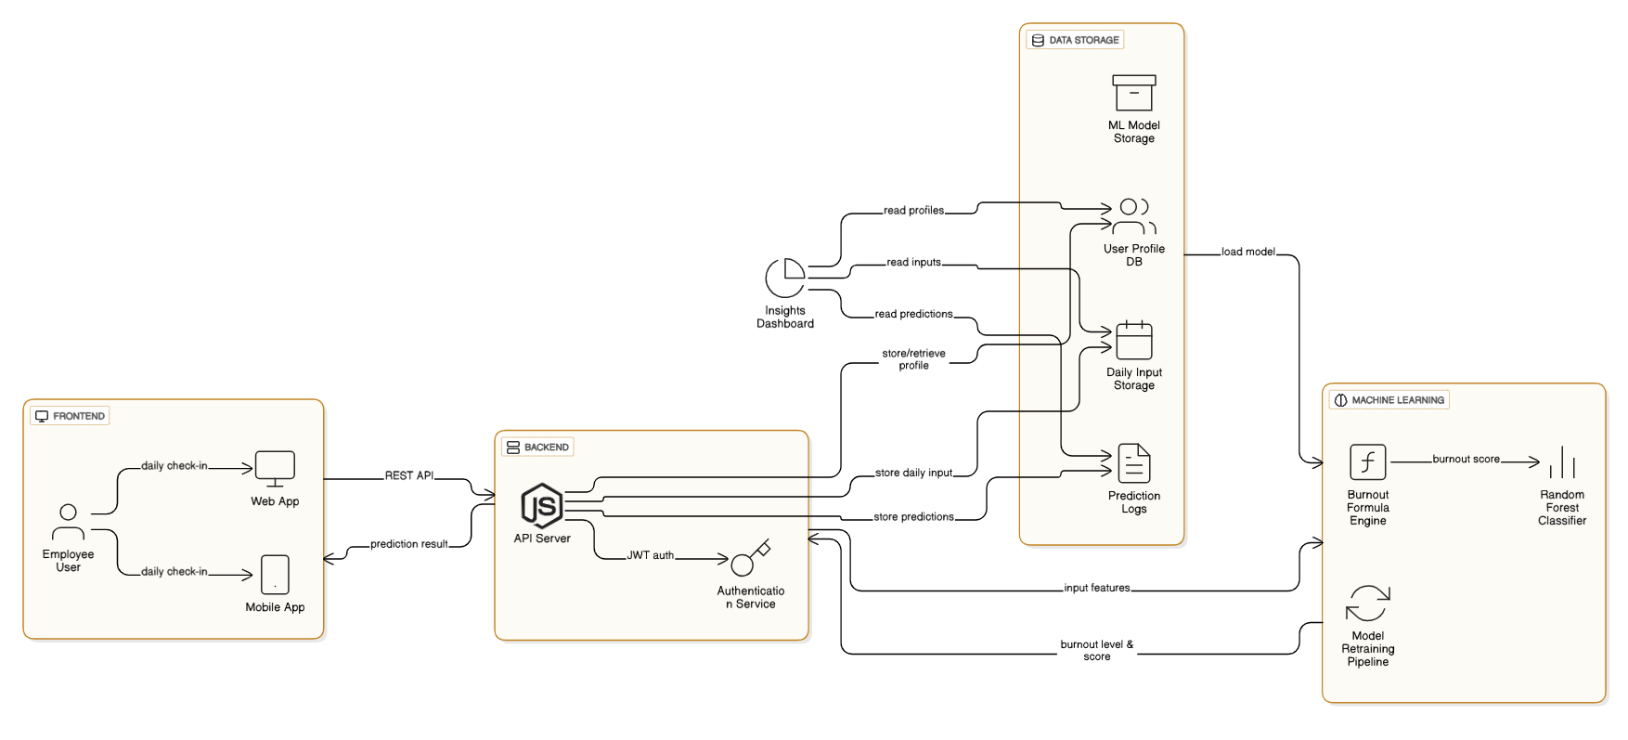
Fig 1.Architecture Diagram

Libraries and Frameworks

- Python (scikit-learn, pandas, joblib): Model training and deployment.
- Node.js and Express: Backend API for processing and routing.
- React & Tailwind CSS: Frontend framework for responsive interfaces.
- Supabase: Authentication, cloud storage, and API management.
- Matplotlib: Visualization of burnout trends for dashboard analytics.

Algorithm Explanation
The Random Forest algorithm is a supervised learning method that constructs multiple decision trees to classify burnout levels. Each tree analyzes a subset of input features, and the final classification is based on majority voting. The algorithm’s ensemble nature minimizes overfitting and improves accuracy.
Additionally, a rule-based burnout formula complements the machine learning model by providing transparent and interpretable scores. For instance, longer work hours and higher stress increase the burnout score, while better sleep and physical activity reduce it. The combination of AI-driven prediction and psychological computation enhances both precision and interpretability—critical in mental health applications.

System and Implementation
Users begin by registering and logging into the platform through Supabase authentication, which ensures secure access and real-time database synchronization. After authentication, each user can input daily wellness data such as work hours, stress levels, mood, sleep quality, and focus through a responsive React-based interface. These inputs are sent to the backend via a RESTful API developed using Node.js and Express.
The backend serves as the core computational engine, validating and pre-processing the data before calculating the burnout score using a psychological rule-based formula. This score provides an immediate numeric indicator of the user’s mental state. The processed data is then passed to the trained Random Forest model, which classifies the burnout level as Low, Medium, or High.
Based on the classification, the backend generates personalized recommendations aimed at improving user well-being—such as encouraging short breaks, balanced workloads, or better sleep routines. The frontend visualizes this information through interactive dashboards displaying burnout trends and daily progress. All user inputs and outputs are securely managed using Supabase’s encrypted storage.
The system was tested on a Windows 11 setup with an Intel i5 processor and 8GB RAM, confirming stable operation and scalability. The architecture can also be deployed on cloud platforms for larger-scale implementations, making it suitable for both individual and organizational wellness monitoring.

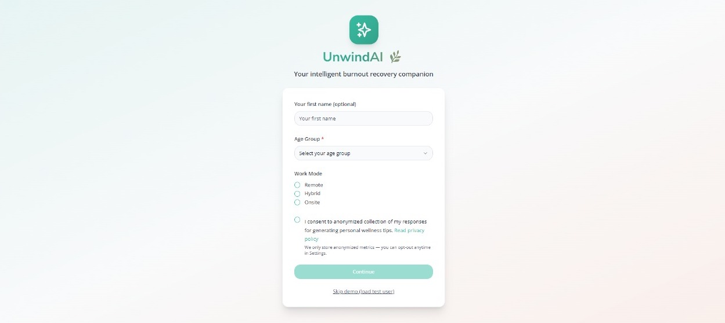
Fig 2. User Login and Sign Up

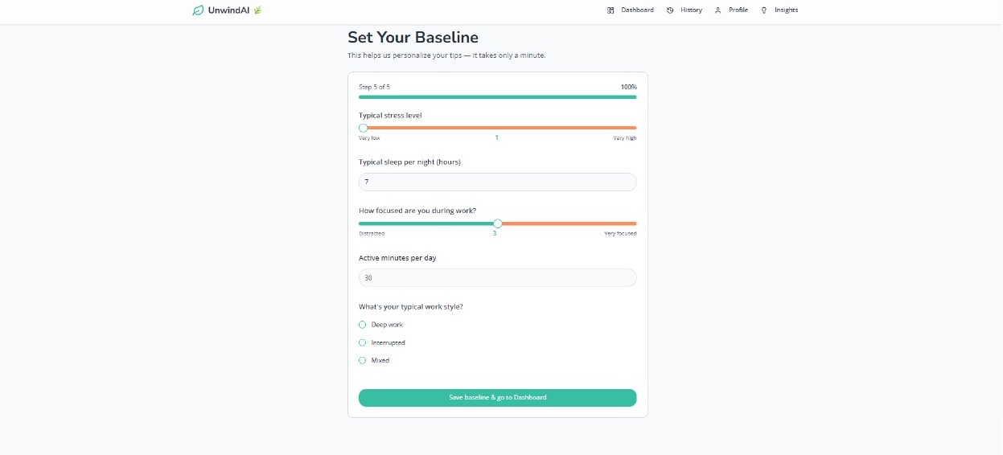
Fig 3.Check-In Questions

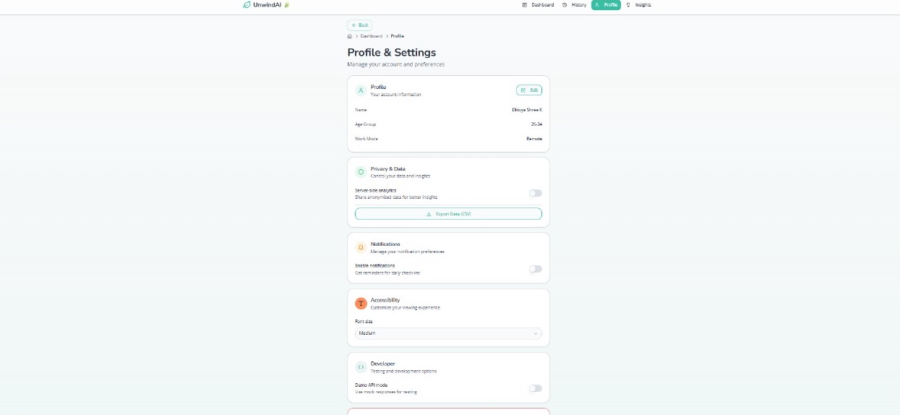
Fig 4. Profile and Settings

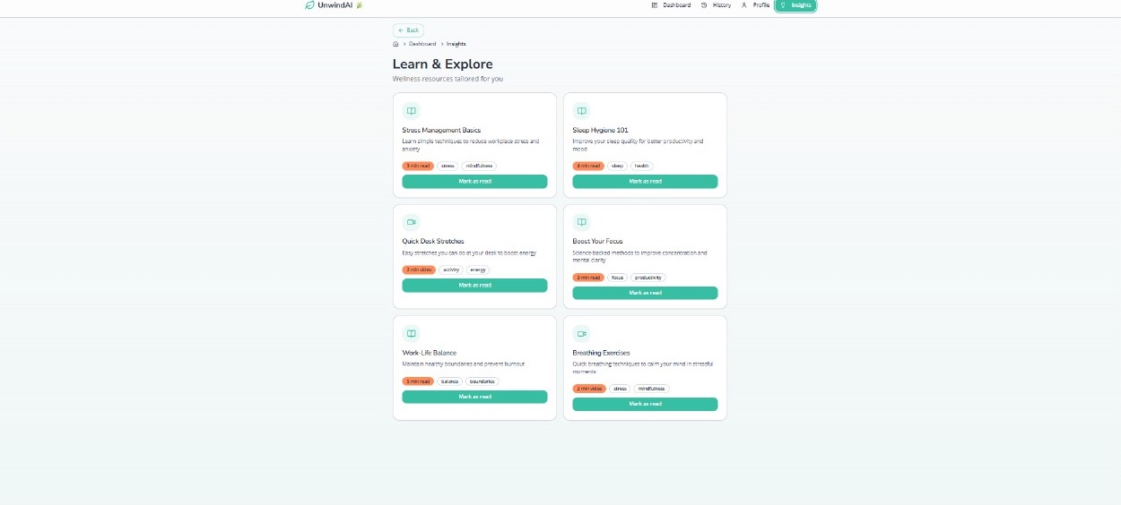
Fig 5. Insights

Implementation
The burnout prediction system achieved an accuracy of 86.7% and an F1 score of 0.79 using test data. The model effectively identified burnout risk across varied inputs. High stress, long work hours, and poor sleep consistently correlated with “High Burnout” predictions, while balanced inputs were labeled “Low Burnout.”
User feedback indicated that real-time recommendations improved daily self-awareness and encouraged healthier work habits. The combination of AI analytics and psychological scoring produced reliable results that aligned with human intuition.
Visualization modules plotted burnout scores over time, allowing users to monitor improvement. These results demonstrate that AI-based monitoring tools can provide effective early intervention, echoing findings from related studies on chatbot-assisted mental wellness [6], [9], [10].
In addition to the overall performance metrics, a detailed classification report and confusion matrix were generated to evaluate the model’s predictive capability across all burnout levels. As shown in Fig. 1, the model achieved an accuracy of 89.56%, precision of 92.78%, recall of 78.93%, and an F1-score of 84.37%, indicating strong generalization and balanced prediction performance. The confusion matrix illustrates that the model correctly identified most instances of Medium Burnout (433 out of 440), High Burnout (72 out of 102), and Low Burnout (61 out of 90). Misclassifications primarily occurred between adjacent burnout levels—such as High being confused with Medium—which is expected due to overlapping behavioral patterns among users. The macro-average precision (0.93) and weighted F1-score (0.89) further confirm that the model performs reliably across all categories. These results validate the robustness of the Random Forest classifier and its suitability for real-world burnout detection scenarios.
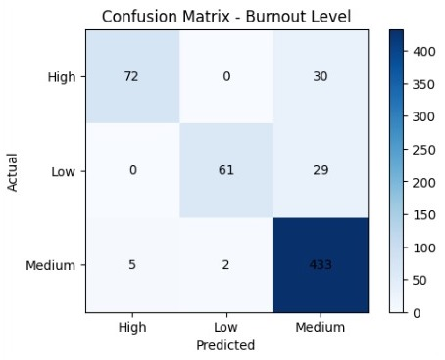
Fig 6. Confusion Matrix

Conclusion
The proposed AI-Driven Burnout and Mental Health Prediction System successfully integrates psychological theory with artificial intelligence to provide a comprehensive approach to workplace well-being. By leveraging a hybrid model that combines rule-based scoring with a machine learning classifier, the system is able to predict burnout levels with high accuracy while maintaining transparency and interpretability—two aspects that are critical in mental health analytics. The web application’s modular architecture ensures scalability, security, and real-time accessibility, making it suitable for deployment across diverse organizational settings. The achieved accuracy of 89.56% and strong precision–recall performance validate the system’s reliability in identifying varying degrees of burnout risk.
Furthermore, the system fosters self-awareness and early intervention, allowing users to recognize behavioral patterns that contribute to mental fatigue and adopt corrective measures promptly. The integration of Supabase for data management and React for an interactive frontend creates a seamless user experience that bridges the gap between technology and emotional well-being.
In the future, this project can be extended by incorporating wearable sensor data (e.g., heart rate, sleep cycles, and physical activity levels) to enable multimodal analysis of mental health. Voice and sentiment recognition modules can enhance emotional understanding, while AI-driven chatbots could provide real-time counseling support and motivational interactions. Additionally, developing an organizational analytics dashboard can empower HR departments to monitor team wellness trends while ensuring anonymity and ethical data use. This research thus establishes a strong foundation for intelligent, empathetic, and ethically responsible mental health monitoring systems that align with the global vision of sustainable and healthy workplaces.

References
- N. Kumar. “Latest Freelance Statistics 2025 – Industry Size & [1] H. Al-Tameemi and F. Chowdhury, “AI-Based Chatbot for Student Mental Health,” Education and Information Technologies, vol. 29, no. 2, pp. 441–459, 2024.
- [2] S. Arora and R. Mehta, “Randomized Trial of a Generative AI Chatbot for Mental Health Treatment (Therabot),” Journal of Digital Health Interventions, vol. 12, no. 3, pp. 214–228, 2025.
- [3] P. Johnson and V. Singh, “Development of a Chatbot for Depression – Adolescent Perceptions,” International Journal of Mental Health Systems, vol. 16, no. 5, p. 56, 2022.
- [4] P. Kowalski and R. Nowak, “Web and Mobile Therapy Chatbot for Subclinical Young Adults,” Cognitive Therapy and Research, vol. 48, no. 2, pp. 305–317, 2024.
- [5] A. Kumar and D. Patel, “Effect of Chatbot Personality on User Engagement,” Proceedings of the MUM Conference on Multimodal Interaction, pp. 341–352, 2022.
- [6] Q. Li and T. Zhang, “Chatbot-Delivered Interventions for Young People: A Systematic Review and Meta-Analysis,” Frontiers in Psychology, vol. 16, no. 7, p. 145–162, 2025.
- [7] X. Liu and Y. Zhou, “Emohaa: A CBT & Emotional Support Chatbot in China,” Computers in Human Behavior, vol. 150, no. 5, p. 107–128, 2023.
- [8] L. O’Shea and K. Williams, “Usability Testing and Trust Analysis of ChatPal: An AI-driven Mental Health Chatbot,” Computers in Human Behavior Reports, vol. 6, no. 2, p. 112–124, 2022.
- [9] L. Rogers and M. Hughes, “AI Conversational Agents for Young People – Systematic Review and Meta-Analysis,” Journal of Affective Disorders Reports, vol. 9, no. 3, p. 245–262, 2025.
- [10] L. Wei and Y. Chen, “CBT-Based AI Chatbot for Depression and Loneliness in Chinese Students: A Randomized Controlled Trial,” BMC Psychiatry, vol. 25, no. 1, p. 85–98, 2025.

